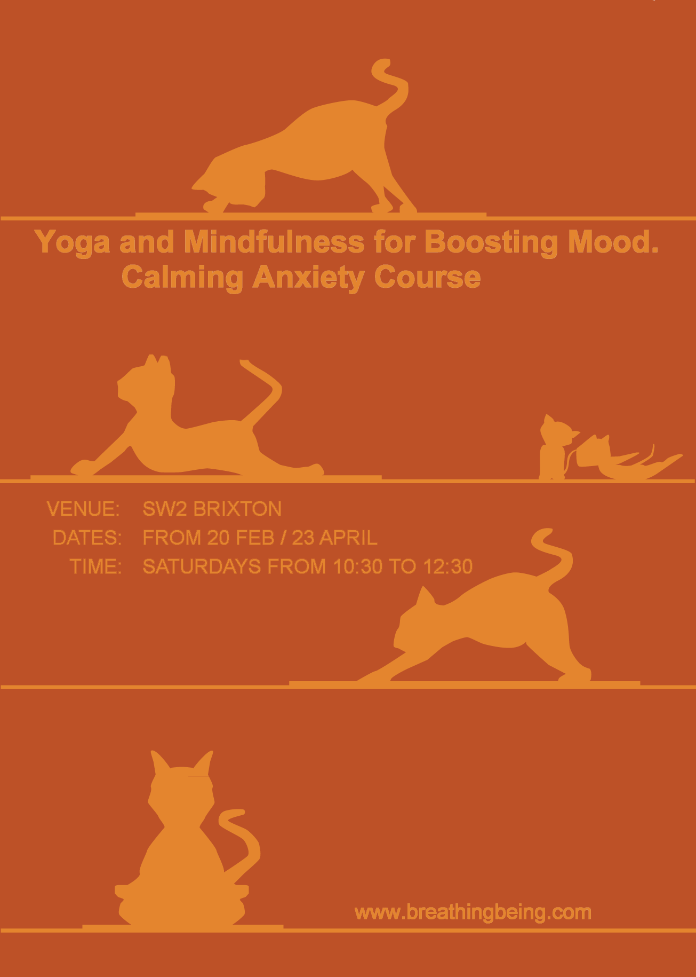

Yoga and Mindfulness for Boosting Mood.
Calming Anxiety Course

10-week course, every Saturday from 10.30 to 12.30 starting in February

Overview

Winter is approaching and for many people this can signal a time when the mood can become low and anxiety can set in. For others low mood can be a more constant feature of life. Yoga therapy offers a range of extremely effective therapeutic techniques that one can learn to help combat such issues.
The course will combine: yoga postures, breathwork, deep relaxation, visualisation linked with creative activities and restorative properties of mindfulness meditation. This course addresses the physiological and psychological dimensions of stress management and anxiety. The sequences in the course are specifically designed to teach participants how to regulate their mood and emotions and rebalance the nervous system.
Course Materials
The yoga course also includes:
- A comprehensive manual
- A Yoga therapy and Mindfulness CD to support daily practice
Teacher Support
During the course every student receives individual attention so you’ll feel safe and supported throughout. Additionally there are opportunities before and after sessions for private discussion with the course teacher.

Previous Yoga and Mindfulness Practice
All levels of yoga and meditation are welcome – you need not worry if you haven’t practised either before.

Booking
To register or further information please contact Raquel on 07910229164 or info@breathingbeing.com

Venue: SW2 Brixton
Dates: From 20 Feb /23 of April
Time: Saturdays from 10.30 to 12.30
Cost: £225 per course

www.breathingbeing.com

