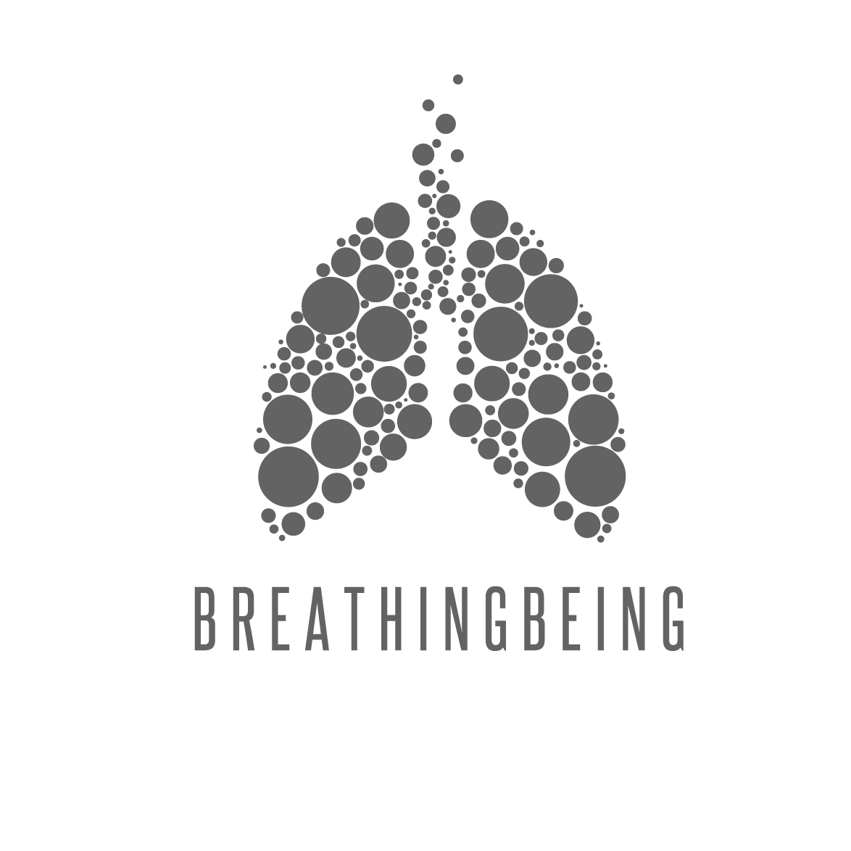

INFORMATION FORM

We will use the information provided to design your Breathing Being programme for you, and for administrative purposes. We will treat the information provided in confidence and will not disclose it to anyone except the partners and employees of Breathing Being without your consent, unless required to do so by law or regulation.

Your details

Name………………………………… Occupation…………………………………….

Email………………………………………………….Phone number……………………………..

Address……………………………………………………………………………………………………………

………………………………………………………………………………………………………………………..

Date of birth………………………………….(dd/mm/yyyy)

Gender……………………………………………….

Your health

- Are you currently taking any medication (prescribed by your doctor or bought over the counter, and including herbal and other supplements)? If so please give details.

………………………………………………………………………………………………

- Have you had any major illnesses or accidents? If so please give details.

………………………………………………………………………………………………

- Do you currently have any health problems? If so please give details, including onset, diagnosis, severity, and treatment.

………………………………………………………………………………………………
………………………………………………………………………………………………
………………………………………………………………………………………………
………………………………………………………………………………………………
………………………………………………………………………………………………

- Do you smoke? Yes / No

- Do you drink alcohol? Yes / No How many units per week?

- Have you been to any alternative or complementary practitioners? If so please give details.

………………………………………………………………………………………………
- Do you engage in any exercise? If so, what and how often?

………………………………………………………………………………………………
………………………………………………………………………………………………
………………………………………………………………………………………………

- Do you feel there are any areas of your body in which you have restricted movement, or otherwise aches/pains/lack of flexibility?

………………………………………………………………………………………………
………………………………………………………………………………………………
………………………………………………………………………………………………

- Please tick any of the following that you currently suffer from or have suffered from in the past:

 | Arthritis |  | Rheumatism
 | Back, shoulder or neck pain |  | Damaged joints or muscles
 | Other back problems
 | High blood pressure |  | Heart problems
 | Low blood pressure |  | Other circulatory disorders
 | Varicose veins
 | Asthma |  | Sinusitis
 | Allergy/hay fever |  | Chronic bronchitis or emphysema
 | Other breathing problem
 | Stomach or duodenal ulcers |  | Constipation
 | Indigestion |  | Hernia
 | Diarrhoea |  | Other digestive disorders
 | Kidney problems |  | Other genito-urinary problems
 | Premenstrual tension |  | Pregnancy or childbirth problems
 | Fibroids |  | Other menstrual problems
 | Menopausal problems
 | Migraine |  | Epilepsy
 | Diabetes |  | Cancer
 | PTSD |  | Insomnia
 | Excessive anxiety |  | Excessive fatigue / ME
 | Eating disorder |  | Other mental health problems
 | Depression |  | Any health problem not listed here

Your constitutional type

Please tick the boxes you feel most apply to you:

 | Vata |  | Pitta |  | Kapha
 | Tall or short (i.e. not medium height), small build |  | Medium height, moderate build |  | Stocky, broad frame
 | Tendency to low weight, prominent veins and bones |  | Moderate weight, good muscles |  | Tendency to overweight
 | Sallow or darkish complexion |  | Ruddy or flushed complexion |  | White/pale complexion
 | Thin / dry / rough / cold skin |  | Warm / pink skin with moles or freckles |  | Thick / white / smooth / moist skin
 | Coarse / dry / wavy or curly hair |  | Moderate / fine / soft hair, or premature baldness |  | Oily hair
 | Small / narrow chest |  | Medium chest |  | Broad chest
 | Thin / dry / cold hands |  | Medium / warm hands |  | Large / cool / firm hands
 | Tendency to constipation |  | Tendency to diarrhoea |  | Tendency to sluggish digestion
 | Variable, erratic appetite |  | Strong appetite |  | Constant appetite
 | Poor / variable / erratic circulation |  | Good circulation, warm body |  | Steady / slow circulation
 | Tendency to quick, erratic activity and hyperactivity |  | Medium activity, purposeful |  | Slow, steady and stately in activity
 | Low endurance, starts and stops quickly, poor stamina |  | Medium endurance and stamina |  | Strong, very good endurance
 | Dislikes cold weather and wind |  | Dislikes hot weather |  | Dislikes cool damp weather
 | Poor resistance to illness |  | Medium resistance to illness |  | Good resistance to illness
 | If ill, tendency to colds, nervous system disorders |  | If ill, tendency to fever, infection, inflammation |  | If ill, tendency to digestive disorders, respiratory disorders, mucus, water retention
 | Quick reaction to medication, low dosage needed |  | Medium reaction to medication |  | Slow reaction to medication, high dosage needed
 | Quick, inconsistent, erratic speech, very talkative |  | Moderate speech, argumentative |  | Slow speech, not talkative
 | Quick mental nature, adaptable, indecisive |  | Intelligent nature, critical |  | Slower mental nature, thoughtful, steady
 | Poor long term memory, quick to catch on but forgets easily |  | Clear memory |  | Slow to learn but good long term memory once learnt
 | Tendency to be fearful, nervous, anxious |  | Tendency to be irritable, critical, angry |  | Tendency to be calm, content, depression

Your lifestyle and preferences

- Do you have a view as to how often would you like to practise?

Once a week / Three times a week / Weekdays only / Weekends only / Daily / Not sure

- How much time do you have available in one block for practice?

Two hours / One hour / 30 minutes / 10 minutes

- If you work, is your job:

Sedentary, office based / Sedentary, other / Active / Manual labour

- What are your daily working hours?

………………………………………………………………………………………….

- Do you have to travel for your job?

Yes, often / Occasionally / No

- How do you travel to and from work?

Car / Train / Bus / Tube / Bicycle / Foot

- When do you feel most energetic:

Morning / Daytime / Evening

- Do you have children? If so, how many and of what age?

………………………………………………………………………………………….

- Do you feel that you would be suited to a yoga practice that is:

Slow and strong / Light and flowing / Energetic and active / Not sure

- Which of the following aspects of yoga interest you (you may circle more than one):
Building strength
Building fitness
Improving flexibility
Working towards mental and emotional balance
Chanting / musical therapy
Spiritual dimension

- Circle any of the following that you feel reflect your personality:
Practical No-nonsense
Creative Open-minded
Spiritual Open-hearted

Confidentiality

BreathingBeing honours your privacy - all information is confidential and every effort will be made to ensure that your identity is protected. All discussions between yoga therapist and client are strictly confidential. There are however some limitations to confidentiality that you need to be aware of: as your yoga therapist, I reserve the right to break confidentiality and contact the appropriate services should you be considered to be a risk of harm to yourself or others. I will make every effort to inform you prior to taking this action

Disclaimer
I have disclosed to my Breathing Being practitioner all information regarding my physical and mental health that is relevant to the practice of yoga. I take full responsibility for all applications of yoga I may practise outside Breathing Being sessions both now and in the future. I fully understand that any recommendations, practices, ideas or techniques expressed and practised in Breathing Being classes cannot be regarded as a substitute for the advice of a Breathing Being practitioner. Any uses to which the same are put by me are at my sole discretion and risk. I understand that yoga is a practice that involves physical movement, breathing, and meditation, which induces specific physiological and psychological changes. I represent that to the best of my knowledge and belief I am able to participate in these aforementioned activities. In the event that I am unsure or if I have questions regarding these practices I will speak to my doctor and my yoga therapy practitioner to receive further counsel and will follow his/her advice.
Whilst it can be hugely beneficial, I know that yoga therapy is not a substitute for any care I may be receiving from a professional primary health care provider and that it is advisable to continue any therapy work, in conjunction with yoga therapy.

I fully understand that any practitioner or therapist recommended to me, or to whom I am referred, by any partner or employee of Breathing Being is not an employee, agent or affiliate of Breathing Being, and neither Breathing Being nor its partners or employees are liable for any act or omission of any such practitioner or therapist. You are responsible for notifying the therapist of any changes to your health or medical conditions that may affect the treatment carried out by the therapist.

Cancellation Policy
We have a 24-hour cancellation policy – appointments not cancelled/cancelled on the day of your session are charged in full. If the customer arrives late he/she will be entitled to the remaining time of the treatment. Should the therapist arrive less than 10 minutes late for your treatment she will still carry out the treatment for the full amount of time that you have booked. Should the therapist arrive more than 15 minutes late or have to cancel a treatment with less than 24 hours notice you will be entitled to a complimentary session.

Signed:

Print:
Date:

